Answers
Task 1
For each of the scenarios given below, tick which hacking techniques have been used. Underline the part(s) in the scenario that support(s) your choice. The first scenario has been completed as an example.
 | Scenario | Virus | Worm | Trojan | Ransomware | Adware | Spyware
1 | Tyler goes to a website that says that it will supply cracked software that doesn’t need a licence. After installing the software, the user is pleased as it works as expected. They notice later that many adverts display on their computer.
2 | Leila clicked on a file in an email attachment. Today, when she turned on her computer it said that all her files are now encrypted. She has been given 24 hours to pay one bitcoin to unencrypt the files.
3 | Richard has downloaded a file from the Internet and run it. After a short while he has noticed that many of the files on his computer have been deleted or corrupted.
5 | A program has been written that targets computers on the Internet. It automatically replicates itself, and whilst it doesn’t harm any individual computers, it does slow down the network.

Task 2
You have been asked to help a user that isn’t that knowledgeable about computer security.
In the table below are some actions that they commonly take. For each action, explain the security risk and what you would advise them to do instead. The first row has been completed for you.
Action taken by user | Security risk | Advice
The user ignores most app updates as sometimes the apps need a username and password to be entered again. | The software will be unpatched / have security issues that are not fixed | Update all apps/software
A user visits a legitimate looking website for their bank. The web address is very slightly different to usual. They enter their username and password to log in, but it says there is an error. | Phishing – the site is likely to be fraudulent and collecting log in details. | Check web addresses carefully.  If the user has been a victim of this, they should contact their bank immediately.
The user is very honest and helpful. They work as a receptionist. When someone phones and asks for information about other staff in the company, such as their full name, they are happy to help. | Social engineering  The person may be trying to find out personal information for a hacking attempt / identity theft. | Do not give away any personal information about others. Verify who is asking for the information. Report any suspicious calls to IT support.

Task 3
Look at the following text message.
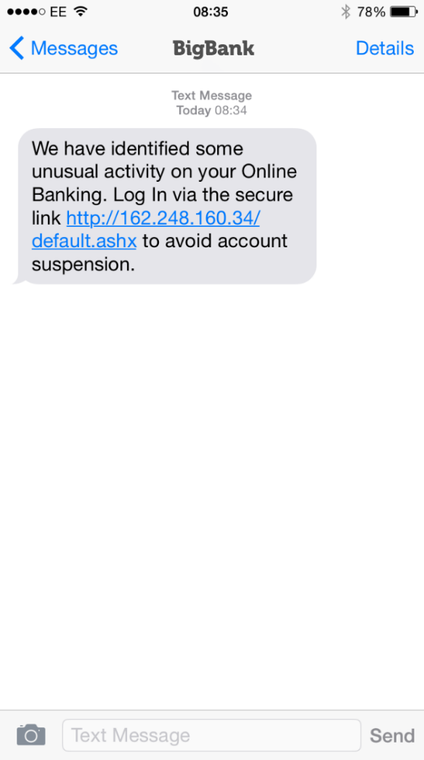
(a) What action should the recipient take?
They should delete the message immediately without clicking on the link.
(b) Give reasons for your answer:
Never trust an email or text message that is not personalised, from a recipient you don’t know or deal with, and which asks you to click on a link. Check the ‘secure link’. This is not a secure site, or the URL would start with https, not http.
Task 4
Draw a diagram to explain how pharming works. Write an additional explanation of how pharming works beneath the diagram.
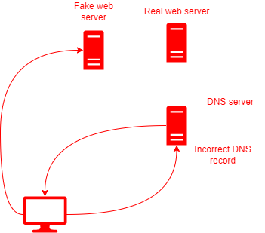
The DNS records are altered either on the DNS server or on a local cached version on the computer/device.
When the web browser looks up the IP address for a domain name, it is given the IP address of a fake web server.
The web page sent back will have been written by the hacker.
If the web page contains a form, the hacker can obtain personal information such as a username and password.
Task 5
1. Carry out some research on Distributed Denial of Service attacks and write up your findings.
Be sure to include answers to the following questions.
- What is a DDoS attack?
- Who is typically targeted?
- Who does it typically affect?
- How can it be countered?
See https://en.wikipedia.org/wiki/Denial-of-service_attack
A DoS attack is an attempt to make a machine, server or network unavailable to its intended users.
Typically, large organisations are attacked, but all users of the site are affected as well as the target.
A huge number of packets of data are sent to one server which causes it not to be able to respond to legitimate requests.
Firewalls, manual settings on switches and routers can all help prevent or reduce the impact of a DOS attack.
A DDoS attack is very similar except it involves many computers involved.

2. Research one or more examples of DoS attacks and write a short description. Cover the following points:
- When did it take place?
- Which country/organisation was affected?
- How many people were affected?
- Who was responsible for the attack?
- What were their motives?
- How was the attack accomplished?
- How can organisations protect themselves?
Sample websites:
https://www.metacompliance.com/blog/10-biggest-ddos-attacks-and-how-your-organisation-can-learn-from-them/
http://www.independent.co.uk/life-style/gadgets-and-tech/worlds-largest-denial-of-service-attack-caused-by-vulnerability-in-the-infrastructure-of-the-web-9122200.html

